Fig. S1

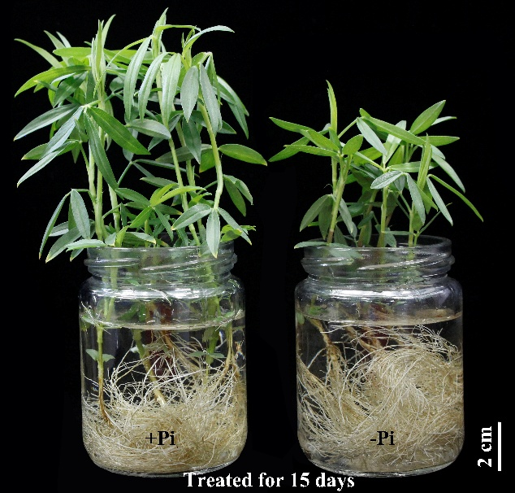

Additional file 1: Fig. S1 Growth performance of stylo at two P levels. Plants were grown in hydroponics for 15 d with (+Pi) or without (−Pi) 250 μmol/L KH₂PO₄ addition. Each bottle contained six plants.

